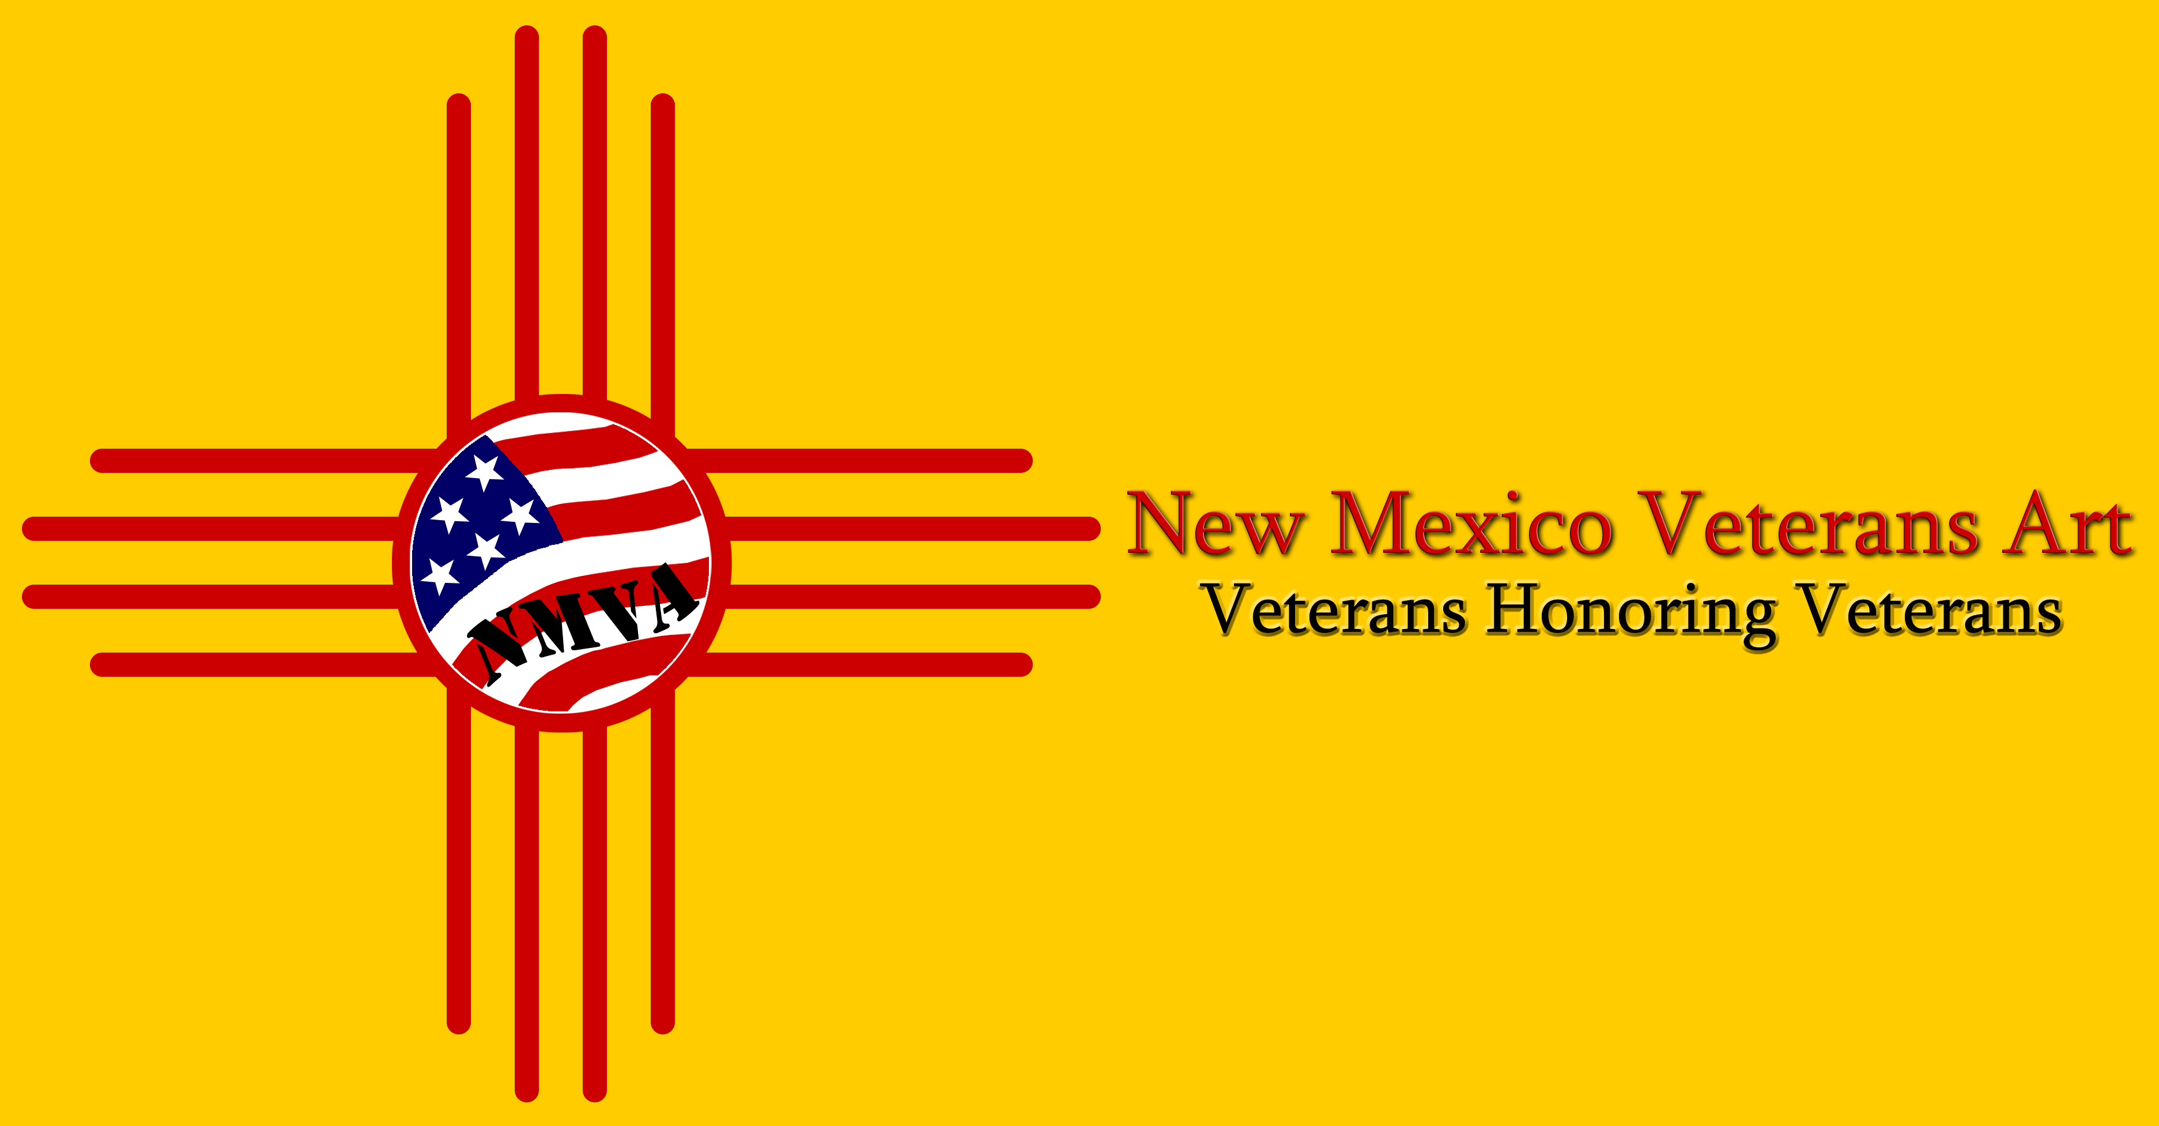 | New Mexico Veterans Art Show 2022
Opening Ceremonies:  November 4, 7:00 PM  (doors open 6:00 PM)  Show Open:  November 5,6,11,12,13,18,19,20,25,26  10:00 AM - 4:00 PM  Fine Arts Bldg - Expo New Mexico | (Artwork by **name here**)
(Artwork by **name here**) | Don’t miss this Fine Arts event honoring our Veterans!
For information, please visit www.NMVeteransArt.com

